Manual divided in 3 parts, list of users and QR codes and setup for Google Authenticator and for Yubikeys

1 - LIST OF QR CODES to be scanned

TOOL: AYDEN

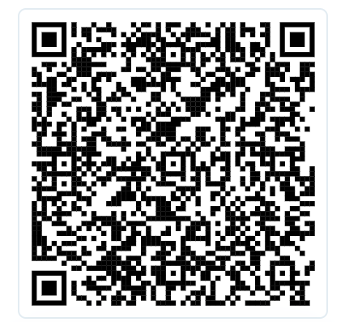

TOOL: Paypal accounts (13 accounts)

Europe

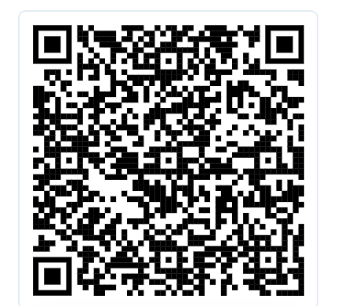

UK:

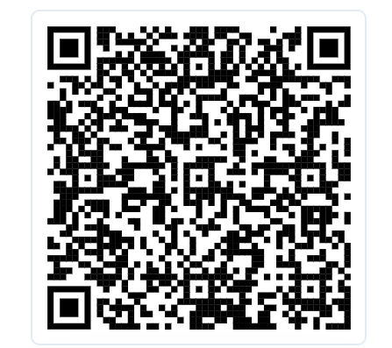

Czech Republic:

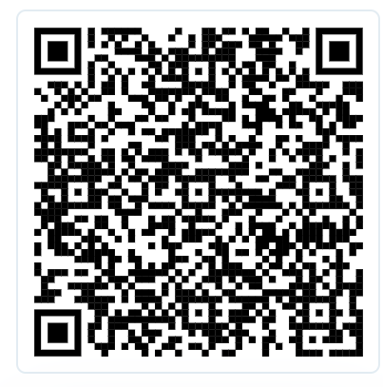

Denmark:

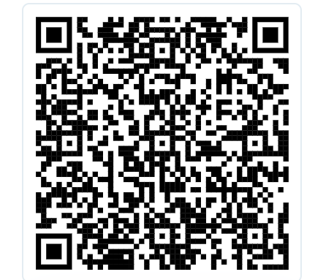

Norway:

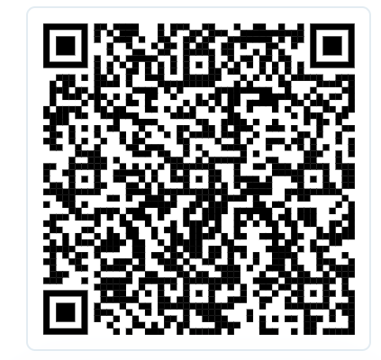

Sweden:

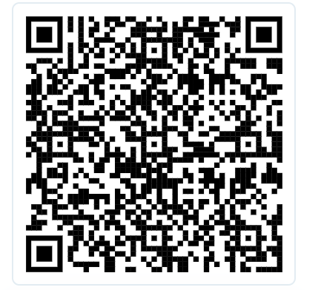

Canada:

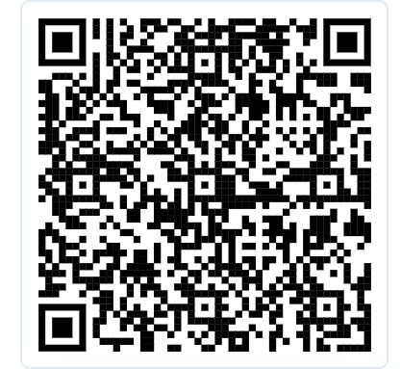

Hong Kong:

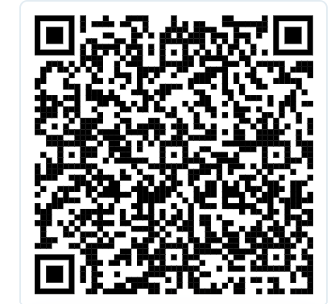

Hungary:

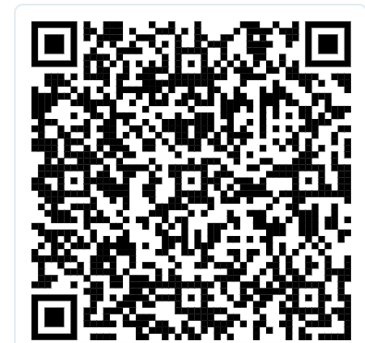

Philippines

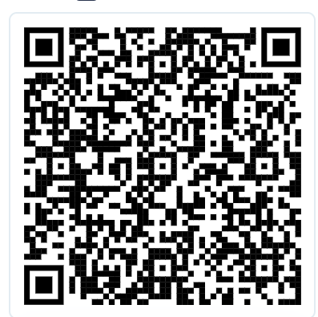

Switzerland:

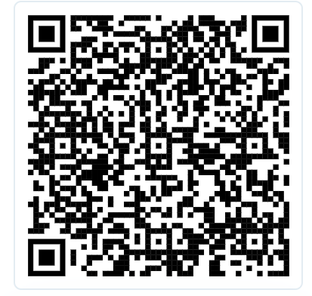

Poland:

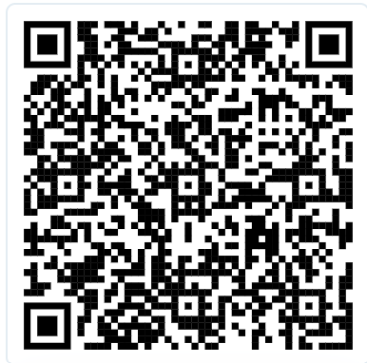

USA.

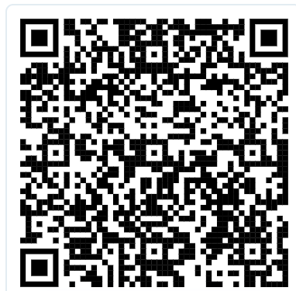

2 - SETUP IN GOOGLE AUTHENTICATOR

* install on the phone the app Google Authenticator (Playstore or IOS)



* when opening app first time, select no SYNC
* add new account with QR

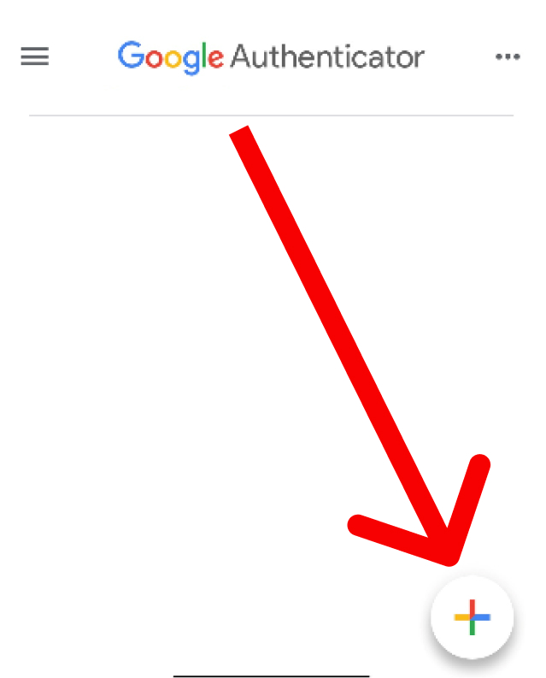

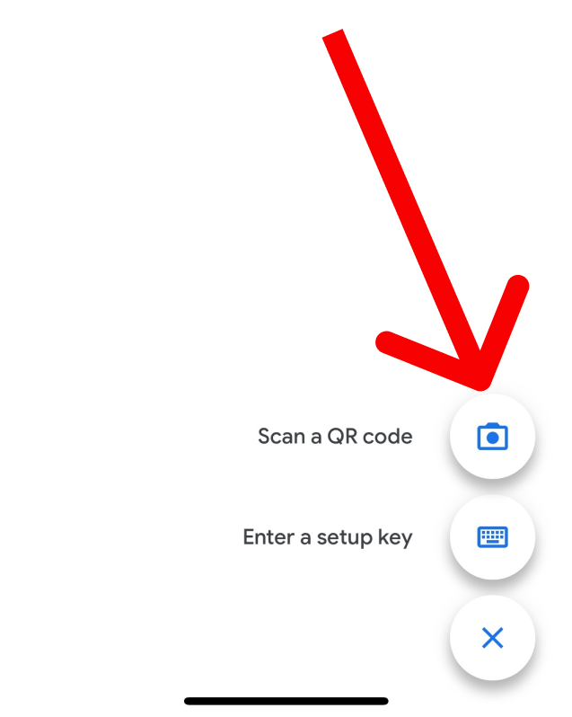

* Scan the QR for the account shared on top and is ready

3 - SETUP FOR YUBIKEY (when available)

* Open APP on the computer (Yubico Authenticator)

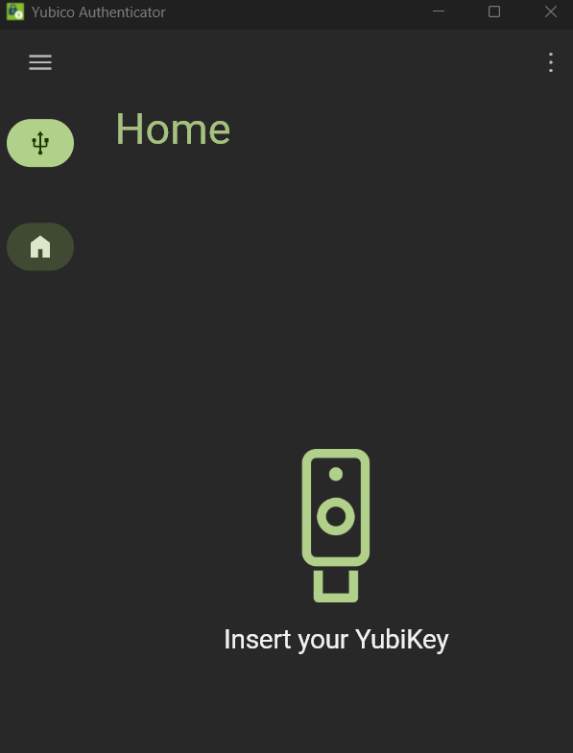

* insert your Yubico key on USB and go to accounts

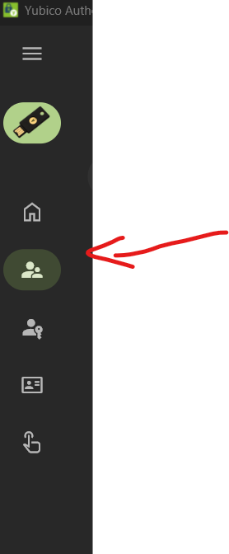

* go to the 3 dots and click on Add account

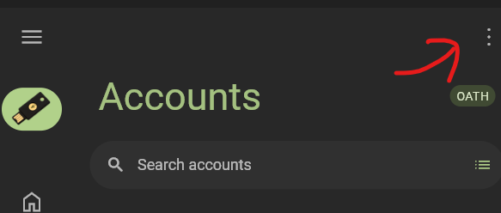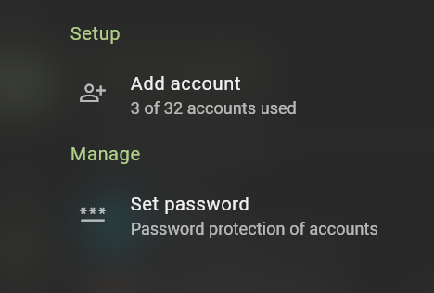

* put you QR you wanna open in background and press scan QR

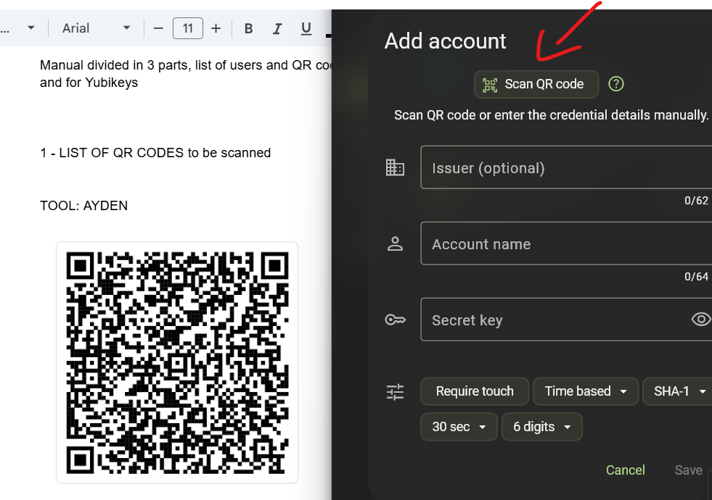

* automatically the info is added, and press Save
* the code is being generated

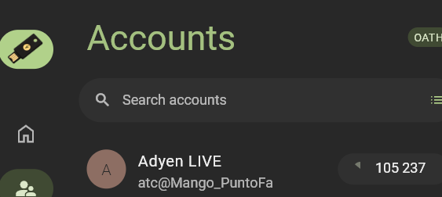

* repeat process to add account for the other accounts